**Parallelogram Theorems**

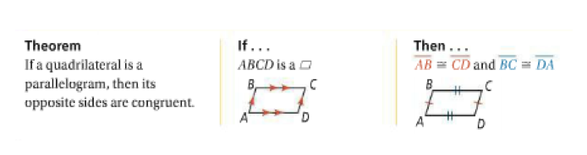

This means: ________________________________________________________________________________  
__________________________________________________________________________________________  
__________________________________________________________________________________________

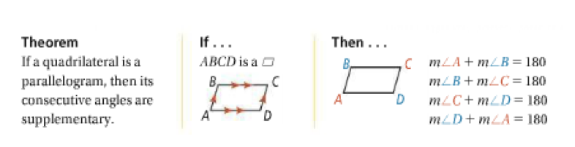

This means: ________________________________________________________________________________  
__________________________________________________________________________________________  
__________________________________________________________________________________________

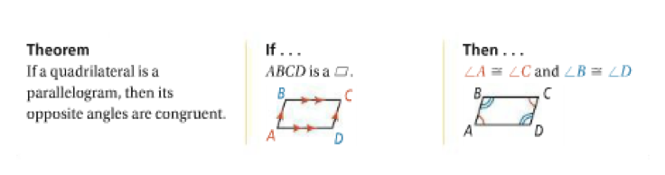

This means: ________________________________________________________________________________  
__________________________________________________________________________________________  
__________________________________________________________________________________________

**Parallelogram Theorems, Part 2**

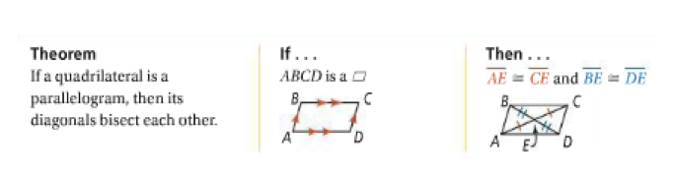

This means: ________________________________________________________________________________  
__________________________________________________________________________________________  
__________________________________________________________________________________________

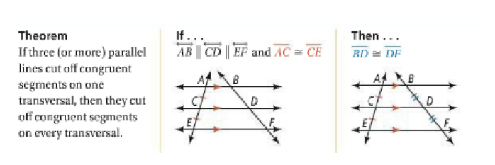

This means: ________________________________________________________________________________  
__________________________________________________________________________________________  
__________________________________________________________________________________________